**EXERCISE NUMBER:1**

**DATE:**14/10/2020

**AIM:**

To write a Python program to print the calendar of a given month and year

**PROGRAM:**

import calendar

year=int(input())

month=int(input())

if(year<10000 and year>999 and month<13 and month>0):

print(calendar.month(year,month))

else:

print("Invalid Input")

**LINK:**

**http://103.53.53.18/mod/vpl/forms/edit.php?id=229&userid=1747**

**OUTPUT:**

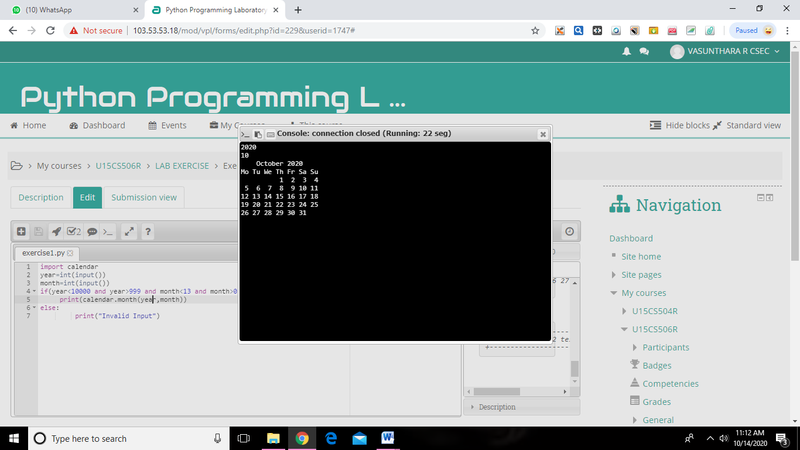

**RESULT:**

The expected output is obtained successfully.